**Name: USANASE Sandrine**

**ID: 24085**

**My Project**

**The Water Access Monitoring and Reporting System** aims to enhance water supply management by providing a platform for residents to report water-related issues through a user-friendly app. The system facilitates real-time monitoring, task assignment, and emergency response integration for water service providers, fostering quick issue resolution, optimizing resource allocation, and promoting community engagement.

**Features**

**Efficient Issue Reporting:**

Residents can easily report water-related problems, such as leaks, disruptions, or quality issues, using a simple and intuitive interface. The user-friendly app minimizes barriers to entry, encouraging widespread participation.

**Real-Time Monitoring:**

The system incorporates real-time monitoring capabilities to track the status of reported issues. This ensures that water service providers have immediate visibility into emerging problems, allowing for prompt response and resolution.

**Transparent Communication:**

The platform establishes transparent communication channels between residents and water service providers. By facilitating direct reporting, residents contribute to a more accurate and comprehensive understanding of the water supply landscape.

**Community Engagement:**

The application fosters community engagement by encouraging residents to actively participate in the management of their water resources. This engagement not only improves the accuracy of issue reporting but also creates a sense of shared responsibility for water infrastructure.

**Data-Driven Decision Making:**

The system accumulates a wealth of data on reported issues, which can be analyzed to identify patterns, hotspots, and recurring problems. Water authorities can use this information for data-driven decision-making, allowing for targeted interventions and more efficient resource allocation.

**Timely Emergency Response:**

In cases of urgent water-related issues or emergencies, the system facilitates rapid response by providing instant alerts to both residents and water service providers. This timely communication helps minimize the impact of critical situations.

**Proactive Maintenance Planning:**

By collecting and analyzing historical data, the system supports proactive maintenance planning. Water authorities can anticipate potential issues, schedule preventive maintenance, and address vulnerabilities in the water supply infrastructure before they escalate.

**Enhanced Customer Satisfaction:**

Residents experience improved satisfaction as the system enables quicker resolution of reported issues. The transparent and responsive nature of the platform fosters trust between residents and water service providers, contributing to overall community satisfaction.

**The database diagram**

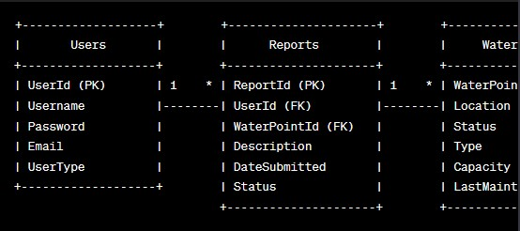

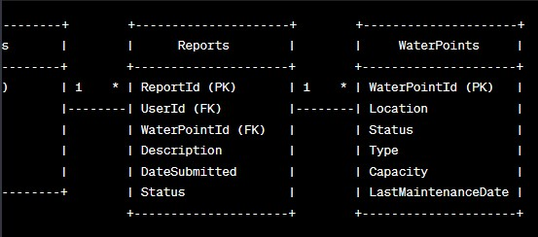

**How do you access the system?**

**User authentication:**

If you are an admin in the process of creating an account, you use admin1@gmail.com.

**This is the login**

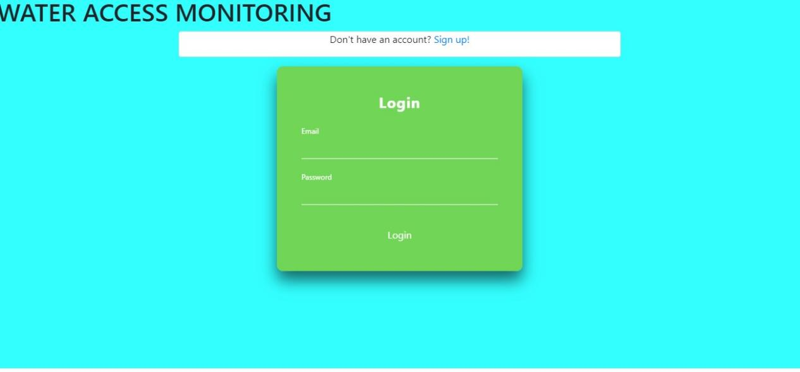

You may not have the account this is

**Signup**

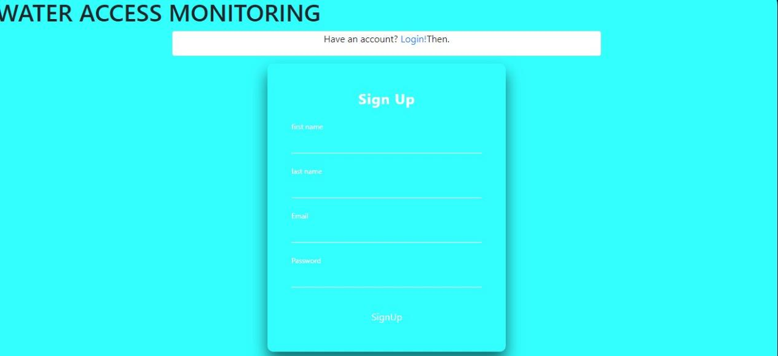

**\**

**After you are prompted to register your claim**

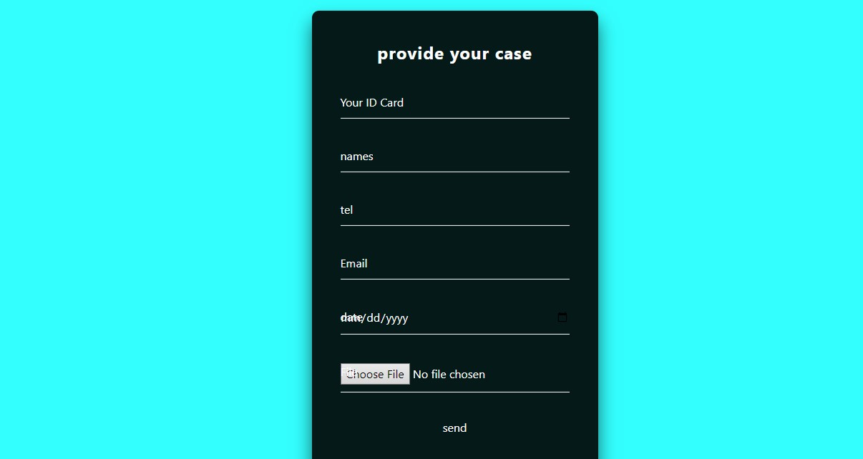

**After registering the claim, you receive an email**

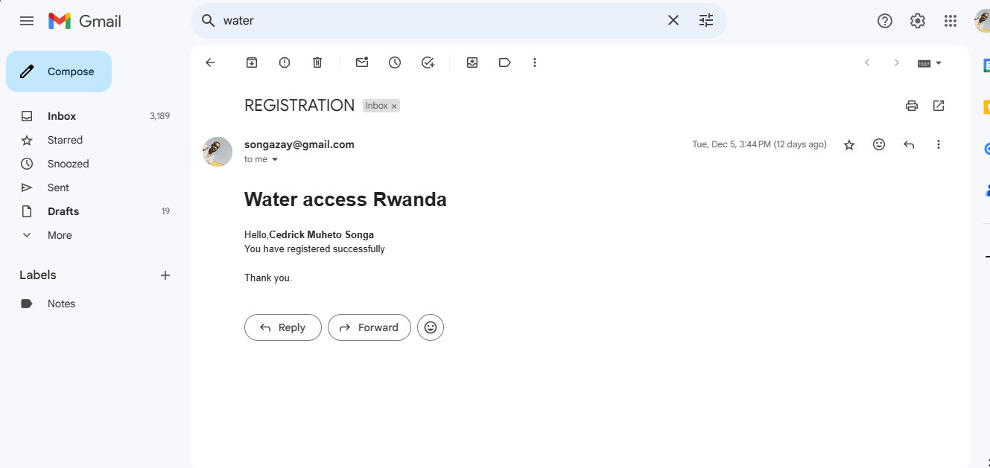

**Then the admin can see the registered claims**

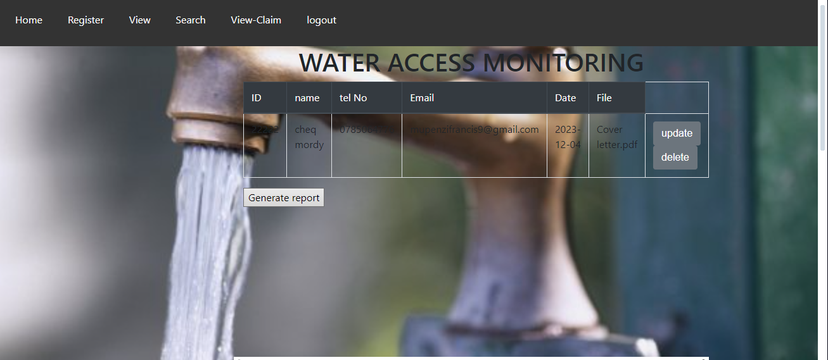

**He updates where necessary and deletes**

**And he can generate reports**

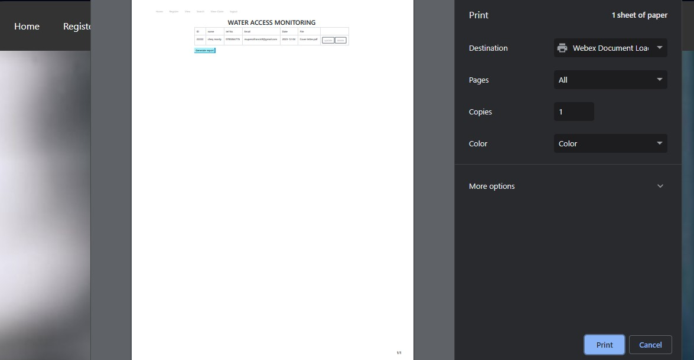

**Thank you!!!**